1. Design DFA using simulator to accept the string having ‘abc’ as substring over the set {a,b,c}

*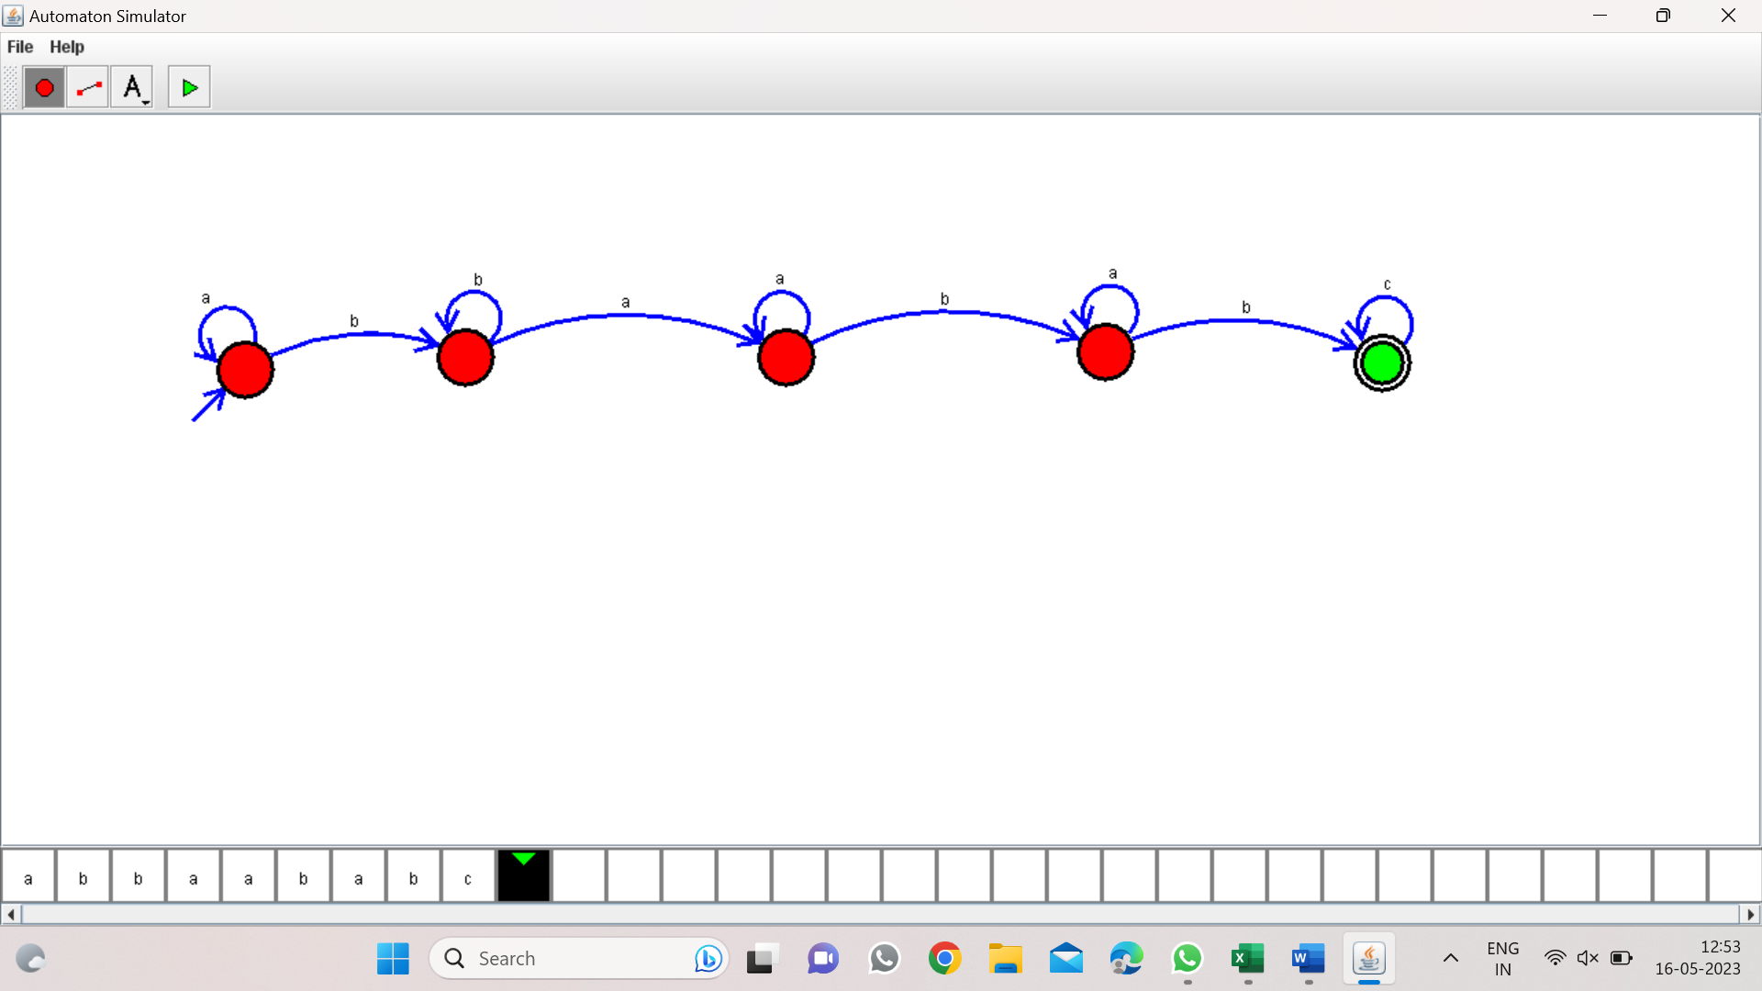*

Result:-

From the above DFA Diagram valid the string having “abc” as a sub string